**PROGRAM 5: AIRLINE FLIGHT DATABASE**

Consider the following database that keeps track of airline flight information:

FLIGHTS(flno: integer, from: string, to: string, distance: integer, departs: time, arrives: time, price: integer)

AIRCRAFT(aid: integer, aname: string, cruisingrange: integer)

CERTIFIED(eid: integer, aid: integer)

EMPLOYEES(eid: integer, ename: string, salary: integer)

Note that the Employees relation describes pilots and other kinds of employees as well; Every pilot is certified for some aircraft, and only pilots are certified to fly.

create database Lab5;

use Lab5;

create table flights(

flno int,

fromplace varchar(15),

toplace varchar(15),

distance int,

departs datetime,

arrives datetime,

price int,

primary key (flno));

desc flights;

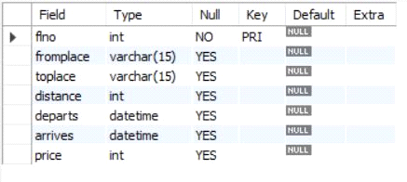

create table aircraft(

aid int,

aname varchar(15),

cruisingrange int,

primary key (aid));

desc aircraft;

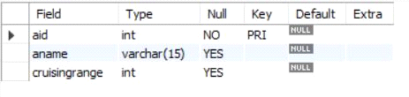

create table employees (

eid int,

ename varchar(15),

salary int,

primary key (eid));

desc employees;

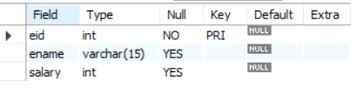

create table certified (

eid int,

aid int,

foreign key (eid) references employees(eid),

foreign key (aid) references aircraft(aid));

desc certified;

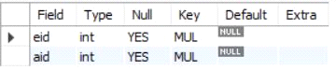

insert into flights values(101, 'Bangalore', 'Delhi', 2500, '2005-05-13 07:15:31', '2005-05-13 18:15:31', 5000);

insert into flights values(102, 'Bangalore', 'Lucknow', 3000, '2013-05-05 07:15:31', '2013-05-05 11:15:31', 6000);

insert into flights values(103, 'Lucknow', 'Delhi', 500, '2013-05-05 12:15:31', '2013-05-05 17:15:31', 3000);

insert into flights values(107, 'Bangalore', 'Frankfurt', 8000, '2013-05-05 07:15:31', '2013-05-05 22:15:31', 60000);

insert into flights values(104, 'Bangalore', 'Frankfurt', 8500, '2013-05-05 07:15:31', '2013-05-05 23:15:31', 75000);

insert into flights values(105, 'Kolkata', 'Delhi', 3400, '2013-05-05 07:15:31', '2013-05-05 09:15:31', 7000);

insert into flights values(106, 'Bangalore', 'Kolkata', 1000, '2013-05-05 01:15:30', '2013-05-05 09:20:30', 10000);

insert into flights values(108, 'Lucknow', 'Kolkata', 1000, '2013-05-05 11:30:30', '2013-05-05 15:20:30', 10000);

select * from flights;

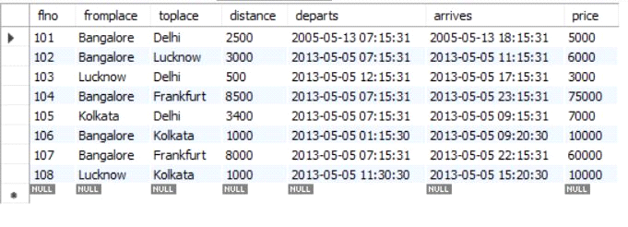

insert into aircraft values(101, '747', 3000);

insert into aircraft values(102, 'Boeing', 900);

insert into aircraft values(103, '647', 800);

insert into aircraft values(104, 'Dreamliner', 10000);

insert into aircraft values(105, 'Boeing', 3500);

insert into aircraft values(106, '707', 1500);

insert into aircraft values(107, 'Dream', 120000);

insert into aircraft values(108, '707', 760);

insert into aircraft values(109, '747', 1000);

select * from aircraft;

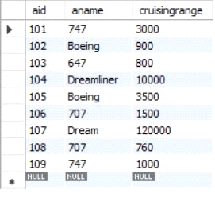

insert into employees values(701, 'A', 50000);

insert into employees values(702, 'B', 100000);

insert into employees values(703, 'C', 150000);

insert into employees values(704, 'D', 90000);

insert into employees values(705, 'E', 40000);

insert into employees values(706, 'F', 60000);

insert into employees values(707, 'G', 90000);

select * from employees;

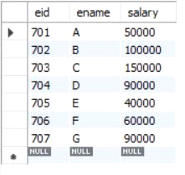

insert into certified values(701, 101);

insert into certified values(701, 102);

insert into certified values(701, 106);

insert into certified values(701, 105);

insert into certified values(702, 104);

insert into certified values(703, 104);

insert into certified values(704, 104);

insert into certified values(702, 107);

insert into certified values(703, 107);

insert into certified values(704, 107);

insert into certified values(702, 101);

insert into certified values(702, 108);

insert into certified values(701, 109);

select * from certified;

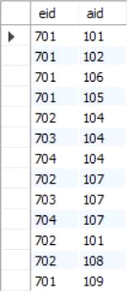

**i.Find the names of aircraft such that all pilots certified to operate them have salaries more than Rs.80,000.**

select distinct a.aname from aircraft a where a.aid in (

select c.aid from certified c, employees e where

c.eid = e.eid and not exists(

select * from employees e1 where e1.eid=e.eid and e1.salary<80000

));

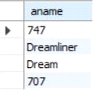

**ii.For each pilot who is certified for more than three aircrafts, find the eid and the maximum cruisingrange of the aircraft for which she or he is certified.**

select max(a.cruisingrange), c.eid from certified c, aircraft a

where c.aid = a.aid group by c.eid having count(c.eid)>3;

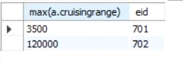

**iii.Find the names of pilots whose salary is less than the price of the cheapest route from Bengaluru to Frankfurt.**

select ename from employees where salary <(

select min(price) from flights where fromplace='Bangalore' and toplace='Frankfurt');

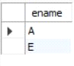

**iv.For all aircraft with cruisingrange over 1000 Kms, find the name of the aircraft and the average salary of all pilots certified for this aircraft.**

select avg(e.salary), c.aid from certified c, employees e where c.aid in(

select aid from aircraft where cruisingrange>1000) and e.eid = c.eid group by c.aid;

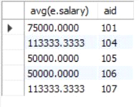

**v.Find the names of pilots certified for some Boeing aircraft.**

select ename from employees where eid in(

select eid from certified where aid in(

select aid from aircraft where aname = 'Boeing'));



**vi.Find the aids of all aircraft that can be used on routes from Bengaluru to New Delhi.**

select aname from aircraft where cruisingrange > any

(select distance from flights where fromplace='Bangalore' and toplace='Delhi');

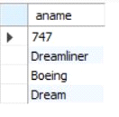

**vii.A customer wants to travel from Bangalore to Kolkata New with no more than two changes of flight. List the choice of departure times from Madison if the customer wants to arrive in Kolkata by 6 p.m.**

select F.flno, F.departs

from flights F

Where F.flno in ( ( select F0.flno

from flights F0

where F0.fromplace = 'Bangalore' and F0.toplace = 'Kolkata'

and extract(hour from F0.arrives) < 18 )

union

( select F0.flno

from flights F0, flights F1

where F0.fromplace = 'Bangalore' and F0.toplace <> 'Kolkata'

and F0.toplace = F1.fromplace and F1.toplace = 'Kolkata'

and F1.departs > F0.arrives

and extract(hour from F1.arrives) < 18)

union

( select F0.flno

from flights F0, flights F1, flights F2

where F0.fromplace = 'Bangalore'

and F0.toplace = F1.fromplace

and F1.toplace = F2.fromplace

and F2.toplace = 'Kolkata'

and F0.toplace <> 'Kolkata'

and F1.toplace <> 'Kolkata'

and F1.departs > F0.arrives

and F2.departs > F1.arrives

and extract(hour from F2.arrives) < 18));

